**Quick Start Booklet (Manual)**

Product that have less will 50 quantity will show a message warning the user.

**Main Menu**

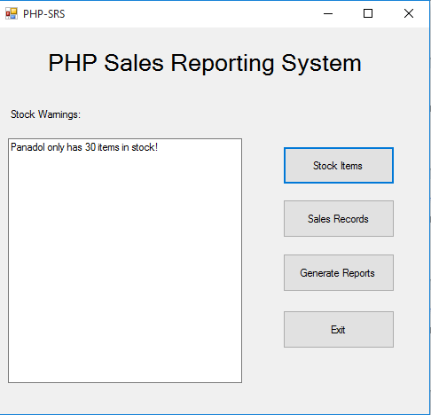

**Adding New Item to Inventory**

**Instructions:**

1. Click on Stock Items from Main Menu.
2. Click on Add New Item
3. Fill into the text boxes (Name, Description, Quantity, and Price).
4. Click on Save

**Image:**

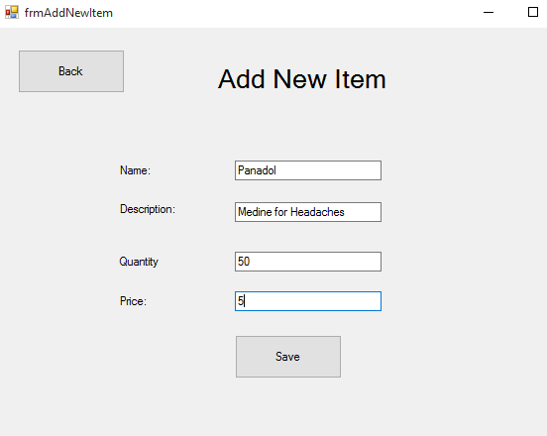

**Updating Item Quantity:**

**Instructions:**

1. Click on Stock Items from Main Menu
2. Click on Update Item
3. Select Item from Dropbox
4. Input the amount of quantity in the quantity textbox.
5. Click on Save.

**Image:**

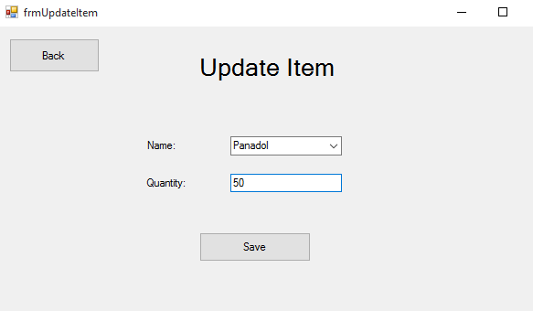

**Viewing Current Stock**

**Instructions:**

1. Click on Stock Items
2. Click on View Current Stock
3. Review the products quantity.

**Image:**

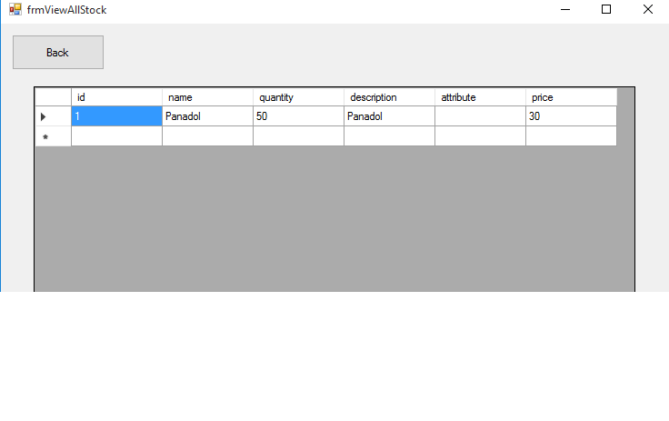

**Sales – Creating Sale Order**

**Instructions**

1. Click on Sales Record
2. Click on Make Sale
3. Select Item from Dropdown box.
4. Enter the amount bought
5. Click on Enter

**Image:**

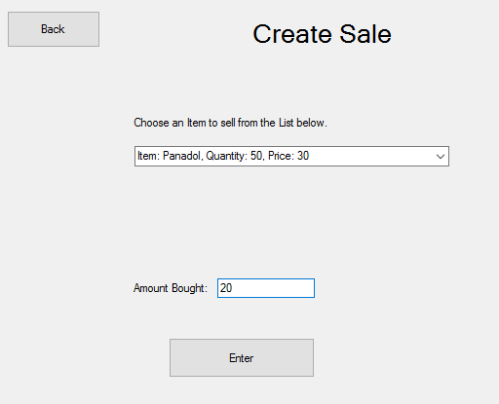

**Viewing Sales Records**

**Instructions:**

1. Click on Sales Records
2. Click on View Sale Records
3. Review Sale Orders.

**Image:**

